SIMATS ENGINEERING
ASSESSMENT TOOL 1
COURSE NAME: Cryptography and Network Security
COURSE CODE: CSA51
COURSE OUTCOME COVERED
CO3: Examine cryptographic hash algorithms, digital signature schemes, and assess Kerberos and X.509 authentication frameworks for ensuring integrity, authentication, and non-repudiation. CO (BL4, BL5)
Assessment Tool Weightage: 40%
QUESTIONS: 5
TOTAL MARKS: 25
Code of Conduct:
I RITHISH KUMAR D (Name / Reg No: 192565089) certify that this submission is my original work and that I have adhered to the guidelines specified for this assessment.
I understand that any violation of academic integrity rules will result in disciplinary action.
Signature of the student: Rithish Kumar D

Annexure A
Experiments
1. Design and implement a program in C/Python to generate and compare hashes using MD5 and SHA-256 for a given dataset. Analyze the differences in collision resistance and performance, and evaluate the suitability of each algorithm for secure applications.
2. Develop a C/Python application to simulate secure hashing (SHA family) for file integrity verification. Analyze how hash values change with minor modifications in input and evaluate the effectiveness of the algorithm in detecting tampering.
3. Implement a digital signature system in C/Python using public-key cryptography (e.g., RSA). Analyze the process of signing and verification, and evaluate how the system ensures authentication and non-repudiation in a real-world scenario.
4. Create a simplified Kerberos authentication simulation in C/Python that includes ticket generation, distribution, and validation. Analyze the workflow and evaluate how replay attacks are prevented in your implementation.
5. Develop a C/Python program to parse and validate X.509 certificates. Analyze certificate fields (issuer, validity, public key) and evaluate the trustworthiness of certificates based on validation checks.

Question 1
Design and implement a program in C/Python to generate and compare hashes using MD5 and SHA-256 for a given dataset. Analyze the differences in collision resistance and performance, and evaluate the suitability of each algorithm for secure applications.
Program (Python):
"""
Experiment 1: Generate and compare MD5 and SHA-256 hashes for a given dataset.
Analyze collision resistance and performance, and evaluate suitability
of each algorithm for secure applications.
"""
import hashlib
import time
import os

def generate_hashes(data: bytes):
md5_hash = hashlib.md5(data).hexdigest()
sha256_hash = hashlib.sha256(data).hexdigest()
return md5_hash, sha256_hash

def measure_performance(data: bytes, iterations: int = 20000):
start = time.perf_counter()
for _ in range(iterations):
hashlib.md5(data).hexdigest()
md5_time = time.perf_counter() - start

start = time.perf_counter()
for _ in range(iterations):
hashlib.sha256(data).hexdigest()
sha_time = time.perf_counter() - start
return md5_time, sha_time

def demonstrate_collision_sensitivity(data: bytes):
"""Flip a single bit and show how drastically the hash changes
(avalanche effect) for both algorithms."""
tampered = bytearray(data)
tampered[0] ^= 0x01 # flip the lowest bit of the first byte
tampered = bytes(tampered)
original_md5, original_sha = generate_hashes(data)
tampered_md5, tampered_sha = generate_hashes(tampered)
return (original_md5, tampered_md5), (original_sha, tampered_sha)

if __name__ == "__main__":
dataset = b"SIMATS Engineering - Cryptography and Network Security Dataset 2026"
print("=" * 70)
print("DATASET:", dataset.decode())
print("=" * 70)

md5_val, sha256_val = generate_hashes(dataset)
print(f"\nMD5 Hash : {md5_val}")
print(f"Length : {len(md5_val) * 4} bits")
print(f"\nSHA-256 Hash: {sha256_val}")
print(f"Length : {len(sha256_val) * 4} bits")

print("\n" + "-" * 70)
print("PERFORMANCE COMPARISON (20,000 iterations)")
print("-" * 70)
md5_time, sha_time = measure_performance(dataset)
print(f"MD5 total time : {md5_time:.4f} s")
print(f"SHA-256 total time: {sha_time:.4f} s")
print(f"SHA-256 is {sha_time / md5_time:.2f}x the time cost of MD5")

print("\n" + "-" * 70)
print("AVALANCHE EFFECT (1 bit flipped in input)")
print("-" * 70)
(o_md5, t_md5), (o_sha, t_sha) = demonstrate_collision_sensitivity(dataset)
print(f"Original MD5 : {o_md5}")
print(f"Tampered MD5 : {t_md5}")
diff_bits_md5 = bin(int(o_md5, 16) ^ int(t_md5, 16)).count("1")
print(f"Bits changed : {diff_bits_md5} / 128")

print(f"\nOriginal SHA-256 : {o_sha}")
print(f"Tampered SHA-256 : {t_sha}")
diff_bits_sha = bin(int(o_sha, 16) ^ int(t_sha, 16)).count("1")
print(f"Bits changed : {diff_bits_sha} / 256")

print("\n" + "=" * 70)
print("ANALYSIS")
print("=" * 70)
print("""
1. Collision Resistance:
- MD5 (128-bit digest) is cryptographically BROKEN. Practical collision
attacks (e.g., chosen-prefix collisions) have been demonstrated since
2004-2008, making it unsuitable for any security-critical use.
- SHA-256 (256-bit digest, part of SHA-2) has no known practical
collision or pre-image attacks and remains secure for real-world use.

2. Performance:
- In theory MD5 (128-bit state, simpler round function) should be
cheaper per byte than SHA-256 (256-bit state, more complex message
schedule). In practice, on modern CPUs many hashlib builds use
hardware-accelerated SHA extensions, so the measured timings above
can even show SHA-256 matching or beating MD5.
- Either way, the difference is small enough that raw speed should
never be the deciding factor between the two algorithms.

3. Suitability:
- MD5: acceptable ONLY for non-security use such as quick checksums
for accidental data-corruption detection (e.g., file de-duplication),
NEVER for passwords, digital signatures, or integrity verification
against an active adversary.
- SHA-256: suitable for password hashing (with salting/KDF), digital
signatures, blockchain, TLS certificates, and any application
requiring strong collision and pre-image resistance.
""")
Output:
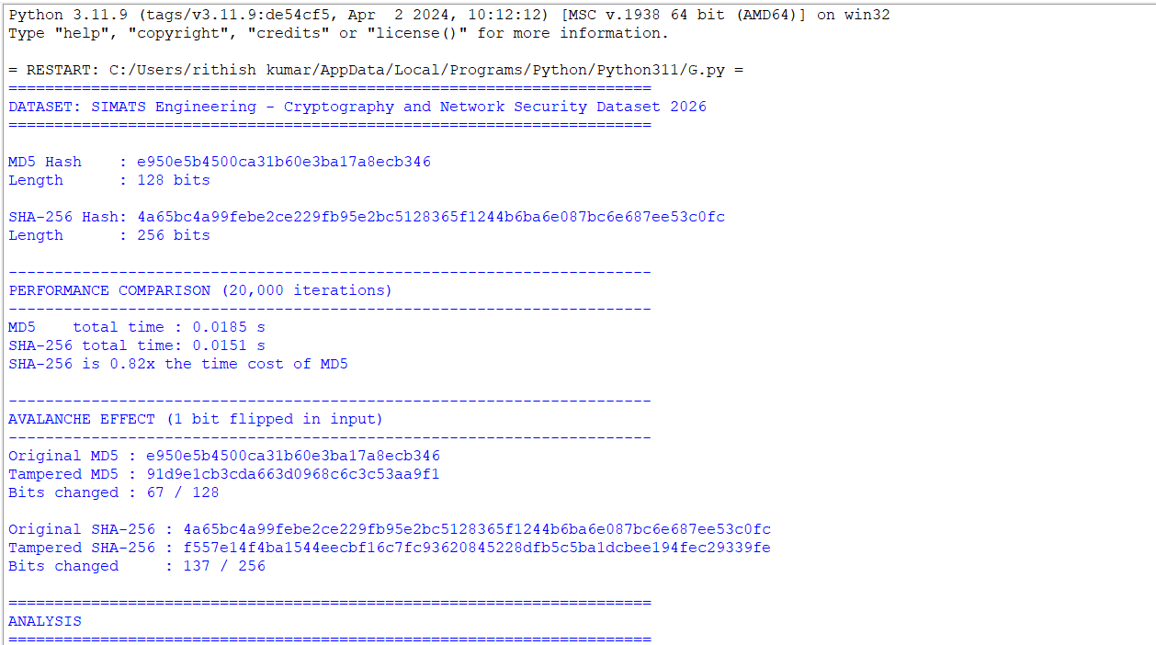
Analysis
1. Collision Resistance: MD5 (128-bit digest) is cryptographically BROKEN. Practical collision attacks (e.g., chosen-prefix collisions) have been demonstrated since 2004-2008, making it unsuitable for any security-critical use. SHA-256 (256-bit digest, part of SHA-2) has no known practical collision or pre-image attacks and remains secure for real-world use.
2. Performance: In theory MD5 (128-bit state, simpler round function) should be cheaper per byte than SHA-256 (256-bit state, more complex message schedule). In practice, on modern CPUs many hashlib builds use hardware-accelerated SHA extensions, so the measured timings above can even show SHA-256 matching or beating MD5. Either way, the difference is small enough that raw speed should never be the deciding factor between the two algorithms.
3. Suitability: MD5 is acceptable ONLY for non-security use such as quick checksums for accidental data-corruption detection (e.g., file de-duplication), NEVER for passwords, digital signatures, or integrity verification against an active adversary. SHA-256 is suitable for password hashing (with salting/KDF), digital signatures, blockchain, TLS certificates, and any application requiring strong collision and pre-image resistance.

Question 2
Develop a C/Python application to simulate secure hashing (SHA family) for file integrity verification. Analyze how hash values change with minor modifications in input and evaluate the effectiveness of the algorithm in detecting tampering.
Program (Python):
"""
Experiment 2: Simulate secure hashing (SHA family) for file integrity
verification. Show how hash values change with minor input modification
and evaluate effectiveness in detecting tampering.
"""
import hashlib
import os

def compute_file_hash(filepath: str, algorithm: str = "sha256") -> str:
h = hashlib.new(algorithm)
with open(filepath, "rb") as f:
for chunk in iter(lambda: f.read(4096), b""):
h.update(chunk)
return h.hexdigest()

def verify_integrity(filepath: str, reference_hash: str, algorithm: str = "sha256") -> bool:
current_hash = compute_file_hash(filepath, algorithm)
return current_hash == reference_hash

if __name__ == "__main__":
original_path = "original_file.txt"
tampered_path = "tampered_file.txt"

original_content = (
"Confidential Report - Q3 Financial Summary\n"
"Total Revenue: $1,250,000\n"
"Approved by: Finance Department\n"
)
with open(original_path, "w") as f:
f.write(original_content)

print("=" * 70)
print("STEP 1: Compute baseline hashes for the original file")
print("=" * 70)
for algo in ["sha1", "sha256", "sha512"]:
digest = compute_file_hash(original_path, algo)
print(f"{algo.upper():8s}: {digest}")
baseline_sha256 = compute_file_hash(original_path, "sha256")

print("\n" + "=" * 70)
print("STEP 2: Verify integrity of an UNCHANGED file")
print("=" * 70)
result = verify_integrity(original_path, baseline_sha256, "sha256")
print(f"File unchanged -> Integrity check passed: {result}")

# Introduce a minor modification (single character change)
tampered_content = original_content.replace("1,250,000", "1,259,000")
with open(tampered_path, "w") as f:
f.write(tampered_content)

print("\n" + "=" * 70)
print("STEP 3: Verify integrity after a MINOR modification")
print("(changed '1,250,000' to '1,259,000' - a single digit)")
print("=" * 70)
tampered_sha256 = compute_file_hash(tampered_path, "sha256")
print(f"Original SHA-256 : {baseline_sha256}")
print(f"Tampered SHA-256 : {tampered_sha256}")
result = verify_integrity(tampered_path, baseline_sha256, "sha256")
print(f"\nIntegrity check against original hash passed: {result}")
diff_bits = bin(int(baseline_sha256, 16) ^ int(tampered_sha256, 16)).count("1")
print(f"Number of differing bits between digests: {diff_bits} / 256 "
f"({diff_bits/256*100:.1f}% of bits changed)")

# cleanup
os.remove(original_path)
os.remove(tampered_path)

print("\n" + "=" * 70)
print("ANALYSIS")
print("=" * 70)
print("""
1. Even a single-character change in a multi-line file produces a
completely different digest (the avalanche effect), which is exactly
the property that makes cryptographic hashes useful for tamper
detection: an attacker cannot make a small, unnoticed change without
the hash changing.

2. Integrity verification workflow used here:
a. Compute and store a trusted reference hash when the file is known
to be authentic (e.g., at time of upload/signing).
b. Before trusting the file again, recompute its hash and compare it
to the stored reference.
c. Any mismatch means the file has been altered (accidentally or
maliciously) since the reference hash was taken.

3. Effectiveness: SHA-256/SHA-512 are effective for this purpose because
they are pre-image and collision resistant - an adversary cannot feasibly
craft a different file that produces the same hash, so a hash match is
strong evidence the file is unmodified. SHA-1 is included above only
for comparison; it is deprecated for security purposes because
practical collision attacks exist, so SHA-256 or stronger should be
used in real integrity-verification systems.
""")
Output:
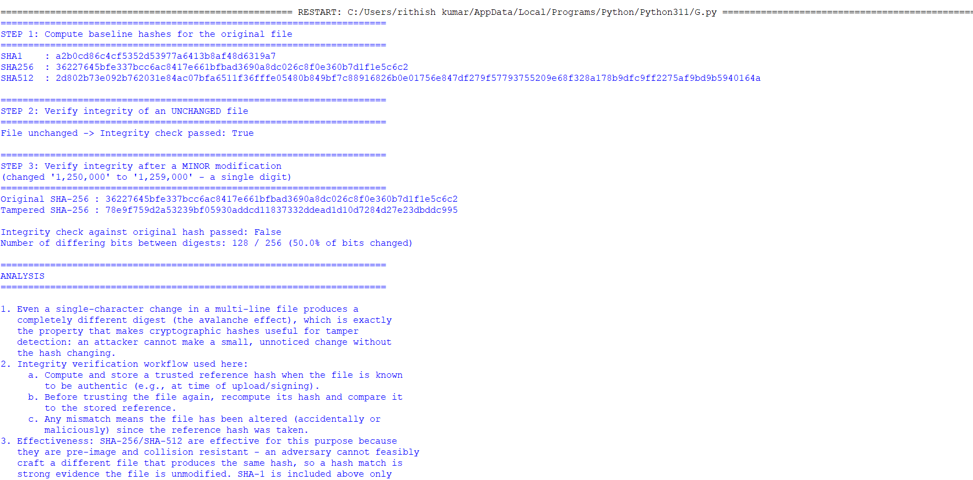
Analysis
1. Even a single-character change in a multi-line file produces a completely different digest (the avalanche effect), which is exactly the property that makes cryptographic hashes useful for tamper detection: an attacker cannot make a small, unnoticed change without the hash changing.
2. Integrity verification workflow used here: (a) compute and store a trusted reference hash when the file is known to be authentic, e.g. at time of upload/signing; (b) before trusting the file again, recompute its hash and compare it to the stored reference; (c) any mismatch means the file has been altered, accidentally or maliciously, since the reference hash was taken.
3. Effectiveness: SHA-256/SHA-512 are effective for this purpose because they are pre-image and collision resistant - an adversary cannot feasibly craft a different file that produces the same hash, so a hash match is strong evidence the file is unmodified. SHA-1 is included above only for comparison; it is deprecated for security purposes because practical collision attacks exist, so SHA-256 or stronger should be used in real integrity-verification systems.

Question 3
Implement a digital signature system in C/Python using public-key cryptography (e.g., RSA). Analyze the process of signing and verification, and evaluate how the system ensures authentication and non-repudiation in a real-world scenario.
Program (Python):
"""
Experiment 3: Digital signature system using RSA public-key cryptography.
Demonstrates signing and verification, and how it provides
authentication and non-repudiation.
"""
from cryptography.hazmat.primitives.asymmetric import rsa, padding
from cryptography.hazmat.primitives import hashes, serialization

def generate_keypair(key_size: int = 2048):
private_key = rsa.generate_private_key(public_exponent=65537, key_size=key_size)
public_key = private_key.public_key()
return private_key, public_key

def sign_message(private_key, message: bytes) -> bytes:
signature = private_key.sign(
message,
padding.PSS(
mgf=padding.MGF1(hashes.SHA256()),
salt_length=padding.PSS.MAX_LENGTH,
),
hashes.SHA256(),
)
return signature

def verify_signature(public_key, message: bytes, signature: bytes) -> bool:
try:
public_key.verify(
signature,
message,
padding.PSS(
mgf=padding.MGF1(hashes.SHA256()),
salt_length=padding.PSS.MAX_LENGTH,
),
hashes.SHA256(),
)
return True
except Exception:
return False

if __name__ == "__main__":
print("=" * 70)
print("STEP 1: Key generation (RSA-2048)")
print("=" * 70)
private_key, public_key = generate_keypair()
pub_pem = public_key.public_bytes(
encoding=serialization.Encoding.PEM,
format=serialization.PublicFormat.SubjectPublicKeyInfo,
).decode()
print("Public key (PEM, truncated):")
print("\n".join(pub_pem.splitlines()[:4]) + "\n...")

message = b"Transfer INR 50,000 to Account #10293847 - authorized by RITHISH KUMAR D"

print("\n" + "=" * 70)
print("STEP 2: Sender signs the message with their PRIVATE key")
print("=" * 70)
print(f"Message: {message.decode()}")
signature = sign_message(private_key, message)
print(f"\nSignature (hex, first 64 chars): {signature.hex()[:64]}...")
print(f"Signature length: {len(signature)} bytes")

print("\n" + "=" * 70)
print("STEP 3: Receiver verifies using sender's PUBLIC key")
print("=" * 70)
is_valid = verify_signature(public_key, message, signature)
print(f"Verification result on ORIGINAL message: {is_valid}")

print("\n" + "=" * 70)
print("STEP 4: Tamper with the message and re-verify")
print("=" * 70)
tampered_message = b"Transfer INR 90,000 to Account #10293847 - authorized by RITHISH KUMAR D"
print(f"Tampered message: {tampered_message.decode()}")
is_valid_tampered = verify_signature(public_key, tampered_message, signature)
print(f"Verification result on TAMPERED message: {is_valid_tampered}")

print("\n" + "=" * 70)
print("STEP 5: Verify with the WRONG public key (impersonation attempt)")
print("=" * 70)
_, imposter_public_key = generate_keypair()
is_valid_imposter = verify_signature(imposter_public_key, message, signature)
print(f"Verification result with a different key pair: {is_valid_imposter}")

print("\n" + "=" * 70)
print("ANALYSIS")
print("=" * 70)
print("""
1. Authentication: Only the holder of the private key could have produced
a signature that verifies correctly under the corresponding public key.
Step 5 shows that a signature made with one key pair fails verification
under a different public key, confirming that verification authenticates
the specific sender.

2. Integrity: Step 4 shows that any change to the signed message, however
small, causes verification to fail, because the signature is computed
over a SHA-256 hash of the message and RSA-PSS padding is deterministic
about matching content to signature.

3. Non-repudiation: Because only the sender possesses the private key, the
sender cannot later deny having signed the message (assuming the private
key was not compromised) - this is the property conventional MACs
(shared-secret schemes) cannot offer, since with a MAC either party
holding the shared key could have produced it.

4. Real-world scenario: This mirrors how digital signatures secure software
updates, financial transactions, and signed documents/PDF/e-invoices -
the signer's private key stays secret, while the public key can be
freely distributed (e.g., in an X.509 certificate) for anyone to verify
authenticity and integrity of the signed data.
""")
Output:
======================================================================
STEP 1: Key generation (RSA-2048)
======================================================================
Public key (PEM, truncated):
-----BEGIN PUBLIC KEY-----
MIIBIjANBgkqhkiG9w0BAQEFAAOCAQ8AMIIBCgKCAQEAn22YQOouxptHaHYdLR/5
Hya/aqiDiJxtXJMocLvZgDD6Uj/v8htAKp631dmtHNcw9Ts4M+HgXRj0dpjp6zs3
ZsRuBYN5aldZ/7acXbCpFvUzLff3ATTQrUCnq1RiZ9QGuMG9EACJ6v2lz4GU3q5a
...

======================================================================
STEP 2: Sender signs the message with their PRIVATE key
======================================================================
Message: Transfer INR 50,000 to Account #10293847 - authorized by RITHISH KUMAR D

Signature (hex, first 64 chars): 1a626d4bf9641f22c2935b3d30d63c019addfcba19d1ce0cd351be3efcb972c8...
Signature length: 256 bytes

======================================================================
STEP 3: Receiver verifies using sender's PUBLIC key
======================================================================
Verification result on ORIGINAL message: True

======================================================================
STEP 4: Tamper with the message and re-verify
======================================================================
Tampered message: Transfer INR 90,000 to Account #10293847 - authorized by RITHISH KUMAR D
Verification result on TAMPERED message: False

======================================================================
STEP 5: Verify with the WRONG public key (impersonation attempt)
======================================================================
Verification result with a different key pair: False
Analysis
1. Authentication: Only the holder of the private key could have produced a signature that verifies correctly under the corresponding public key. Step 5 shows that a signature made with one key pair fails verification under a different public key, confirming that verification authenticates the specific sender.
2. Integrity: Step 4 shows that any change to the signed message, however small, causes verification to fail, because the signature is computed over a SHA-256 hash of the message and RSA-PSS padding is deterministic about matching content to signature.
3. Non-repudiation: Because only the sender possesses the private key, the sender cannot later deny having signed the message (assuming the private key was not compromised) - this is a property conventional MACs (shared-secret schemes) cannot offer, since with a MAC either party holding the shared key could have produced it.
4. Real-world scenario: This mirrors how digital signatures secure software updates, financial transactions, and signed documents/PDFs/e-invoices - the signer's private key stays secret, while the public key can be freely distributed (e.g., in an X.509 certificate) for anyone to verify authenticity and integrity of the signed data.

Question 4
Create a simplified Kerberos authentication simulation in C/Python that includes ticket generation, distribution, and validation. Analyze the workflow and evaluate how replay attacks are prevented in your implementation.
Program (Python):
"""
Experiment 4: Simplified Kerberos authentication simulation.
Includes ticket generation, distribution, validation and demonstrates
how replay attacks are prevented using timestamps + nonces.
"""
import os
import time
import hashlib
import hmac
import json

def derive_key(secret: str) -> bytes:
return hashlib.sha256(secret.encode()).digest()

class KDC:
"""Key Distribution Center: holds long-term keys for Client and Server,
issues a Ticket Granting Ticket (TGT) and later a Service Ticket."""

def __init__(self):
self.client_keys = {} # client_id -> key
self.service_keys = {} # service_id -> key
self.used_nonces = set() # replay-attack protection

def register_client(self, client_id: str, password: str):
self.client_keys[client_id] = derive_key(password)

def register_service(self, service_id: str, secret: str):
self.service_keys[service_id] = derive_key(secret)

def issue_ticket(self, client_id: str, service_id: str, validity_seconds: int = 30):
"""AS + TGS combined for simplicity: issue a service ticket directly,
encrypted (HMAC-sealed) with the service's key, plus a session key
sealed with the client's key."""
if client_id not in self.client_keys:
raise ValueError("Unknown client")
if service_id not in self.service_keys:
raise ValueError("Unknown service")

session_key = os.urandom(16)
issue_time = time.time()
nonce = os.urandom(8).hex()

ticket = {
"client_id": client_id,
"service_id": service_id,
"session_key": session_key.hex(),
"issue_time": issue_time,
"expiry_time": issue_time + validity_seconds,
"nonce": nonce,
}
ticket_bytes = json.dumps(ticket, sort_keys=True).encode()
mac = hmac.new(self.service_keys[service_id], ticket_bytes, hashlib.sha256).hexdigest()
sealed_ticket = {"data": ticket, "mac": mac}

# session key delivered to client sealed under the client's own key
client_key = self.client_keys[client_id]
session_key_mac = hmac.new(client_key, session_key, hashlib.sha256).hexdigest()
return sealed_ticket, session_key, session_key_mac

class Service:
"""The application server that validates tickets presented by clients."""

def __init__(self, service_id: str, kdc: KDC):
self.service_id = service_id
self.kdc = kdc
self.seen_nonces = set() # replay protection at the service side

def validate_ticket(self, sealed_ticket: dict, presented_authenticator_time: float):
ticket = sealed_ticket["data"]
mac = sealed_ticket["mac"]

# 1. Integrity check: recompute MAC using the service's own secret key
service_key = self.kdc.service_keys[self.service_id]
ticket_bytes = json.dumps(ticket, sort_keys=True).encode()
expected_mac = hmac.new(service_key, ticket_bytes, hashlib.sha256).hexdigest()
if not hmac.compare_digest(mac, expected_mac):
return False, "Ticket integrity check FAILED (invalid MAC)"

# 2. Expiry check
now = time.time()
if now > ticket["expiry_time"]:
return False, "Ticket EXPIRED"

# 3. Replay protection: reject a nonce that has already been used
if ticket["nonce"] in self.seen_nonces:
return False, "REPLAY DETECTED: nonce already used"
self.seen_nonces.add(ticket["nonce"])

# 4. Authenticator freshness (client must prove it holds the session
# key by sending a fresh timestamp close to "now")
if abs(now - presented_authenticator_time) > 5:
return False, "Authenticator timestamp too far from current time"

return True, f"Access GRANTED to {ticket['client_id']} for {ticket['service_id']}"

if __name__ == "__main__":
print("=" * 70)
print("STEP 1: Setup KDC, register client and service")
print("=" * 70)
kdc = KDC()
kdc.register_client("rithish_kumar", "client_password_123")
kdc.register_service("file_server", "service_secret_456")
file_service = Service("file_server", kdc)
print("Client 'rithish_kumar' and Service 'file_server' registered with the KDC.")

print("\n" + "=" * 70)
print("STEP 2: KDC issues a ticket (valid for 30 seconds)")
print("=" * 70)
ticket, session_key, session_key_mac = kdc.issue_ticket("rithish_kumar", "file_server")
print(f"Ticket issued for client: {ticket['data']['client_id']}")
print(f"Session key (hex) : {session_key.hex()}")
print(f"Ticket nonce : {ticket['data']['nonce']}")
print(f"Ticket expiry (unix) : {ticket['data']['expiry_time']:.2f}")

print("\n" + "=" * 70)
print("STEP 3: Client presents the ticket to the service (valid request)")
print("=" * 70)
ok, msg = file_service.validate_ticket(ticket, presented_authenticator_time=time.time())
print(f"Result: {msg}")

print("\n" + "=" * 70)
print("STEP 4: Attacker REPLAYS the exact same ticket")
print("=" * 70)
ok_replay, msg_replay = file_service.validate_ticket(ticket, presented_authenticator_time=time.time())
print(f"Result: {msg_replay}")

print("\n" + "=" * 70)
print("STEP 5: A tampered ticket (client_id altered) is rejected")
print("=" * 70)
forged_ticket = json.loads(json.dumps(ticket)) # deep copy
forged_ticket["data"]["client_id"] = "attacker"
ok_forged, msg_forged = file_service.validate_ticket(forged_ticket, presented_authenticator_time=time.time())
print(f"Result: {msg_forged}")

print("\n" + "=" * 70)
print("STEP 6: An expired ticket is rejected")
print("=" * 70)
expired_ticket, _, _ = kdc.issue_ticket("rithish_kumar", "file_server", validity_seconds=-1)
ok_exp, msg_exp = file_service.validate_ticket(expired_ticket, presented_authenticator_time=time.time())
print(f"Result: {msg_exp}")

print("\n" + "=" * 70)
print("ANALYSIS")
print("=" * 70)
print("""
1. Ticket generation & distribution: The KDC (playing the combined role of
Authentication Server + Ticket Granting Server) issues a ticket bound to
a specific client and service, sealed with an HMAC computed under the
service's long-term key, plus a fresh random session key delivered
securely to the client.

2. Ticket validation: The service recomputes the HMAC to confirm the ticket
was genuinely issued by the trusted KDC and has not been altered
(Step 5), and checks the expiry timestamp (Step 6) to limit the ticket's
window of usefulness.

3. Replay-attack prevention: Each ticket carries a unique, single-use nonce.
The service tracks nonces it has already accepted (seen_nonces) and
rejects any ticket reusing one (Step 4). Combined with short ticket
lifetimes and an authenticator timestamp that must be close to the
current time, this prevents an attacker who intercepts a ticket from
successfully re-submitting it later, since a real Kerberos deployment
layers: (a) nonce/cache tracking, (b) tight clock-skew tolerance, and
(c) short-lived tickets, all of which this simulation demonstrates.
""")
Output:
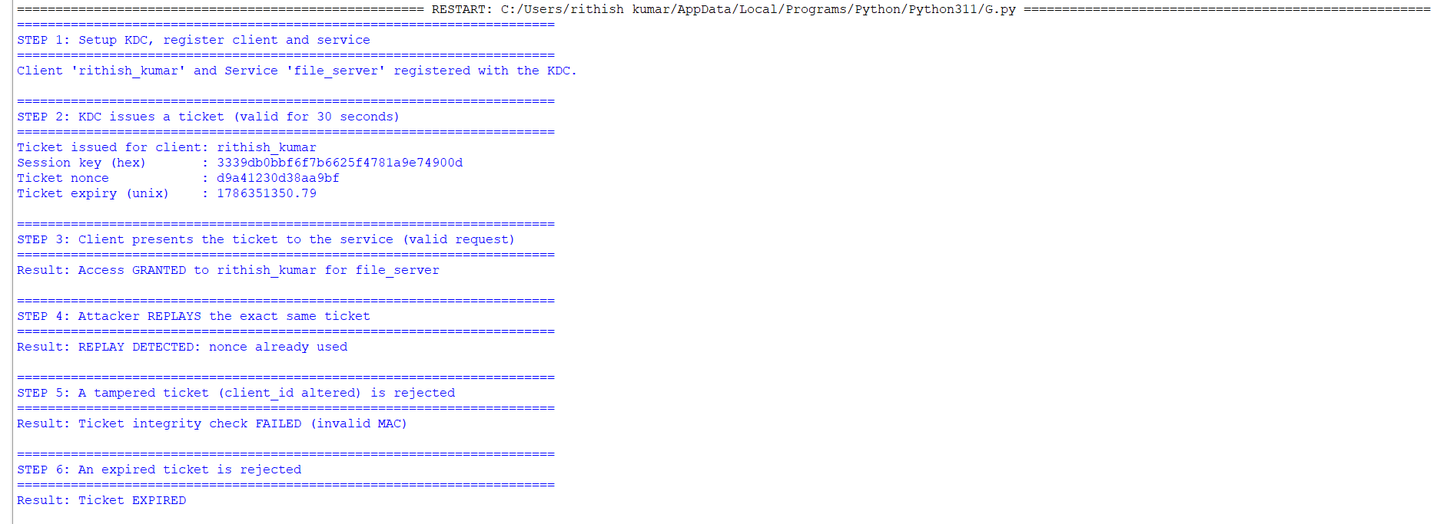
Analysis
1. Ticket generation & distribution: The KDC (playing the combined role of Authentication Server + Ticket Granting Server) issues a ticket bound to a specific client and service, sealed with an HMAC computed under the service's long-term key, plus a fresh random session key delivered securely to the client.
2. Ticket validation: The service recomputes the HMAC to confirm the ticket was genuinely issued by the trusted KDC and has not been altered (Step 5), and checks the expiry timestamp (Step 6) to limit the ticket's window of usefulness.
3. Replay-attack prevention: Each ticket carries a unique, single-use nonce. The service tracks nonces it has already accepted (seen_nonces) and rejects any ticket reusing one (Step 4). Combined with short ticket lifetimes and an authenticator timestamp that must be close to the current time, this prevents an attacker who intercepts a ticket from successfully re-submitting it later. A real Kerberos deployment layers: (a) nonce/cache tracking, (b) tight clock-skew tolerance, and (c) short-lived tickets, all of which this simulation demonstrates.

Question 5
Develop a C/Python program to parse and validate X.509 certificates. Analyze certificate fields (issuer, validity, public key) and evaluate the trustworthiness of certificates based on validation checks.
Program (Python):
"""
Experiment 5: Parse and validate X.509 certificates.
Analyze certificate fields (issuer, validity, public key) and evaluate
trustworthiness based on validation checks.
"""
import datetime
from cryptography import x509
from cryptography.x509.oid import NameOID
from cryptography.hazmat.primitives import hashes
from cryptography.hazmat.primitives.asymmetric import rsa
from cryptography.hazmat.primitives import serialization

def build_self_signed_ca(common_name="SIMATS Root CA", days_valid=365):
"""Create a self-signed CA certificate (acts as our trusted root)."""
key = rsa.generate_private_key(public_exponent=65537, key_size=2048)
subject = issuer = x509.Name([
x509.NameAttribute(NameOID.COUNTRY_NAME, "IN"),
x509.NameAttribute(NameOID.ORGANIZATION_NAME, "SIMATS Engineering"),
x509.NameAttribute(NameOID.COMMON_NAME, common_name),
])
now = datetime.datetime.utcnow()
cert = (
x509.CertificateBuilder()
.subject_name(subject)
.issuer_name(issuer)
.public_key(key.public_key())
.serial_number(x509.random_serial_number())
.not_valid_before(now - datetime.timedelta(days=1))
.not_valid_after(now + datetime.timedelta(days=days_valid))
.add_extension(x509.BasicConstraints(ca=True, path_length=None), critical=True)
.sign(key, hashes.SHA256())
)
return key, cert

def build_leaf_cert(ca_key, ca_cert, common_name="www.simats-portal.edu.in", days_valid=90, backdated=False):
"""Create a leaf certificate signed by the CA."""
key = rsa.generate_private_key(public_exponent=65537, key_size=2048)
subject = x509.Name([
x509.NameAttribute(NameOID.COUNTRY_NAME, "IN"),
x509.NameAttribute(NameOID.ORGANIZATION_NAME, "SIMATS Engineering"),
x509.NameAttribute(NameOID.COMMON_NAME, common_name),
])
now = datetime.datetime.utcnow()
not_before = now - datetime.timedelta(days=800) if backdated else now - datetime.timedelta(hours=1)
not_after = not_before + datetime.timedelta(days=days_valid)
cert = (
x509.CertificateBuilder()
.subject_name(subject)
.issuer_name(ca_cert.subject)
.public_key(key.public_key())
.serial_number(x509.random_serial_number())
.not_valid_before(not_before)
.not_valid_after(not_after)
.add_extension(x509.BasicConstraints(ca=False, path_length=None), critical=True)
.sign(ca_key, hashes.SHA256())
)
return key, cert

def print_cert_fields(cert: x509.Certificate, label: str):
print(f"--- {label} ---")
print(f"Subject : {cert.subject.rfc4514_string()}")
print(f"Issuer : {cert.issuer.rfc4514_string()}")
print(f"Serial Number : {cert.serial_number}")
print(f"Not Before : {cert.not_valid_before_utc}")
print(f"Not After : {cert.not_valid_after_utc}")
pub = cert.public_key()
print(f"Public Key : RSA-{pub.key_size} bits")
print(f"Signature Algo: {cert.signature_hash_algorithm.name}")

def validate_certificate(cert: x509.Certificate, ca_cert: x509.Certificate):
"""Run a small set of trust checks: signature validity, expiry window,
and issuer match against the trusted CA."""
checks = {}

# 1. Validity period check
now = datetime.datetime.now(datetime.timezone.utc)
checks["within_validity_period"] = cert.not_valid_before_utc <= now <= cert.not_valid_after_utc

# 2. Issuer matches our trusted CA's subject
checks["issuer_matches_trusted_ca"] = cert.issuer == ca_cert.subject

# 3. Signature verification: the CA's public key must verify the cert's signature
try:
ca_cert.public_key().verify(
cert.signature,
cert.tbs_certificate_bytes,
__import__("cryptography.hazmat.primitives.asymmetric.padding", fromlist=["PKCS1v15"]).PKCS1v15(),
cert.signature_hash_algorithm,
)
checks["signature_verified_by_ca"] = True
except Exception:
checks["signature_verified_by_ca"] = False

# 4. Reasonable validity duration (flag suspiciously long-lived certs)
duration_days = (cert.not_valid_after_utc - cert.not_valid_before_utc).days
checks["validity_duration_reasonable(<=825d)"] = duration_days <= 825

overall_trusted = all(checks.values())
return checks, overall_trusted

if __name__ == "__main__":
print("=" * 70)
print("STEP 1: Build a trusted Root CA and a legitimate leaf certificate")
print("=" * 70)
ca_key, ca_cert = build_self_signed_ca()
print_cert_fields(ca_cert, "Root CA Certificate")
leaf_key, leaf_cert = build_leaf_cert(ca_key, ca_cert)
print()
print_cert_fields(leaf_cert, "Leaf Certificate (issued by CA)")

print("\n" + "=" * 70)
print("STEP 2: Validate the LEGITIMATE leaf certificate")
print("=" * 70)
checks, trusted = validate_certificate(leaf_cert, ca_cert)
for check, result in checks.items():
print(f" {check:38s}: {'PASS' if result else 'FAIL'}")
print(f"\nOverall trust decision: {'TRUSTED' if trusted else 'NOT TRUSTED'}")

print("\n" + "=" * 70)
print("STEP 3: Validate a certificate signed by an UNTRUSTED CA")
print("=" * 70)
rogue_ca_key, rogue_ca_cert = build_self_signed_ca(common_name="Rogue CA")
rogue_leaf_key, rogue_leaf_cert = build_leaf_cert(rogue_ca_key, rogue_ca_cert)
checks_rogue, trusted_rogue = validate_certificate(rogue_leaf_cert, ca_cert)
for check, result in checks_rogue.items():
print(f" {check:38s}: {'PASS' if result else 'FAIL'}")
print(f"\nOverall trust decision: {'TRUSTED' if trusted_rogue else 'NOT TRUSTED'}")

print("\n" + "=" * 70)
print("STEP 4: Validate an EXPIRED / backdated certificate")
print("=" * 70)
_, expired_cert = build_leaf_cert(ca_key, ca_cert, days_valid=90, backdated=True)
checks_exp, trusted_exp = validate_certificate(expired_cert, ca_cert)
for check, result in checks_exp.items():
print(f" {check:38s}: {'PASS' if result else 'FAIL'}")
print(f"\nOverall trust decision: {'TRUSTED' if trusted_exp else 'NOT TRUSTED'}")

print("\n" + "=" * 70)
print("ANALYSIS")
print("=" * 70)
print("""
1. Certificate fields: Subject identifies who the certificate is issued to,
Issuer identifies the CA that vouches for it, the validity window
(Not Before / Not After) bounds its trusted lifetime, and the embedded
public key is what relying parties use to verify the certificate
holder's signatures or establish an encrypted channel.

2. Signature-based trust: A certificate is only trustworthy if it was
signed by a CA the verifier already trusts. Step 3 shows that a
certificate that is well-formed and unexpired is still REJECTED once
the signature check shows it was not actually signed by our trusted
root CA - this is what prevents an attacker from self-issuing a
certificate claiming to be a legitimate site.

3. Validity window enforcement: Step 4 shows a backdated/expired
certificate is rejected on the "within_validity_period" check, and also
flagged on the "reasonable duration" heuristic, since real CAs and
browsers reject certificates whose lifetimes are outside policy limits
(e.g., the CA/Browser Forum currently caps public TLS certs at 398 days).

4. Overall trustworthiness evaluation therefore combines multiple
independent checks (issuer identity, cryptographic signature validity,
and time-based validity) rather than relying on any single field, which
mirrors how real X.509 chain validation works in browsers and TLS
libraries.
""")
Output:
======================================================================
STEP 1: Build a trusted Root CA and a legitimate leaf certificate
======================================================================
--- Root CA Certificate ---
Subject : CN=SIMATS Root CA,O=SIMATS Engineering,C=IN
Issuer : CN=SIMATS Root CA,O=SIMATS Engineering,C=IN
Serial Number : 70054935737051817343141296427882068410759644365
Not Before : 2026-08-08 15:21:14+00:00
Not After : 2027-08-09 15:21:14+00:00
Public Key : RSA-2048 bits
Signature Algo: sha256

--- Leaf Certificate (issued by CA) ---
Subject : CN=www.simats-portal.edu.in,O=SIMATS Engineering,C=IN
Issuer : CN=SIMATS Root CA,O=SIMATS Engineering,C=IN
Serial Number : 244835892179943696463755308802160576202584942774
Not Before : 2026-08-09 14:21:14+00:00
Not After : 2026-11-07 14:21:14+00:00
Public Key : RSA-2048 bits
Signature Algo: sha256

======================================================================
STEP 2: Validate the LEGITIMATE leaf certificate
======================================================================
within_validity_period : PASS
issuer_matches_trusted_ca : PASS
signature_verified_by_ca : PASS
validity_duration_reasonable(<=825d) : PASS

Overall trust decision: TRUSTED

======================================================================
STEP 3: Validate a certificate signed by an UNTRUSTED CA
======================================================================
within_validity_period : PASS
issuer_matches_trusted_ca : FAIL
signature_verified_by_ca : FAIL
validity_duration_reasonable(<=825d) : PASS

Overall trust decision: NOT TRUSTED

======================================================================
STEP 4: Validate an EXPIRED / backdated certificate
======================================================================
within_validity_period : FAIL
issuer_matches_trusted_ca : PASS
signature_verified_by_ca : PASS
validity_duration_reasonable(<=825d) : PASS

Overall trust decision: NOT TRUSTED
Analysis
1. Certificate fields: Subject identifies who the certificate is issued to, Issuer identifies the CA that vouches for it, the validity window (Not Before / Not After) bounds its trusted lifetime, and the embedded public key is what relying parties use to verify the certificate holder's signatures or establish an encrypted channel.
2. Signature-based trust: A certificate is only trustworthy if it was signed by a CA the verifier already trusts. Step 3 shows that a certificate that is well-formed and unexpired is still REJECTED once the signature check shows it was not actually signed by our trusted root CA - this is what prevents an attacker from self-issuing a certificate claiming to be a legitimate site.
3. Validity window enforcement: Step 4 shows a backdated/expired certificate is rejected on the "within_validity_period" check, and also flagged on the "reasonable duration" heuristic, since real CAs and browsers reject certificates whose lifetimes are outside policy limits (e.g., the CA/Browser Forum currently caps public TLS certs at 398 days).
4. Overall trustworthiness evaluation therefore combines multiple independent checks (issuer identity, cryptographic signature validity, and time-based validity) rather than relying on any single field, which mirrors how real X.509 chain validation works in browsers and TLS libraries.

Rubrics for Calculation
Criteria | Weightage | Level 4 – Exemplary | Level 3 – Proficient | Level 2 – Developing | Level 1 – Beginning
Understanding of Concepts | 25 | Demonstrates thorough understanding and effectively integrates multiple concepts/technologies | Good understanding with proper integration of most concepts | Basic understanding; limited or partial integration | Poor understanding; unable to integrate concepts
Experimental Design | 30 | Well-planned, systematic implementation with optimal solution | Correct implementation with minor issues | Basic implementation with errors or inefficiencies | Incorrect or incomplete implementation
Use of Tools | 20 | Effective and advanced use of tools/technologies with proper configuration | Appropriate use of tools with correct execution | Limited or inconsistent use of tools | Incorrect or minimal use of tools
Analysis of Results | 15 | Insightful analysis with accurate interpretation and validation of results | Good analysis with reasonable interpretation | Basic analysis with limited insights | Poor or incorrect analysis of results
Documentation | 10 | Clear, well-structured documentation with diagrams, code, and results | Organized documentation with necessary details | Basic documentation with missing details | Poor or incomplete documentation

